

**Trimester: I/II/III Subject: Programming and Problem Solving**

**Name**: Krishnaraj Thadesar **Division:** 9

**Roll No.:** 109054 **Batch:** I3

**Experiment No.:** 1A

**Name of the Experiment:** Algorithm and Flowchart to log into a Gmail Account

**Performed on:** 16nd December 2021

**Submitted on:** 23rd December 2021

**AIM:**

1. Write an algorithm and draw a flowchart to log in to GMAIL account.

**OBJECTIVE:**

1. To understand importance of flowchart for any programming model.
2. To learn simple flowchart symbols and arrows to define relationships.
3. To understand and develop visual representations of the flow of data.

**THEORY:**

Draw and explain following basic flowchart symbols-

1. Terminal

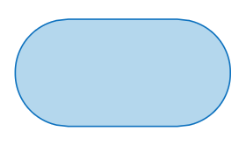

The terminator symbol marks the starting or ending point of the system. It usually contains the word "Start" or "End."

1. Input/output



Represents material or information entering or leaving the system, such as customer order (input) or a product (output).

1. Decision

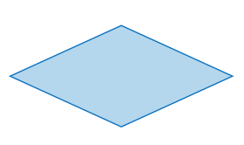

A decision or branching point. Lines representing different decisions emerge from different points of the diamond.

1. Flow lines

**Flow lines** indicate the process' direction. Each **flowline** usually connects two blocks. **Flowlines** can be straight lines, uni-directional arrow, or both-sided arrow.

1. Connectors

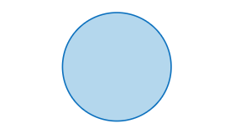

Indicates that the flow continues where a matching symbol (containing the same letter) has been placed.

# PLATFORM: 64 –bit Windows 11.

**INPUT ALGORITHM:**

Step 1: Open Browser

Step 2: Visit https://mail.google.com/mail

Step 3: Enter your Username, or Mail ID

Step 4: Enter your password

Step 5: If Password is correct, Log into Account

Step 6: If Password is wrong, Either go to Forgot Password or Try again.

Step 7: Stop or Close Browser.

**OUTPUT FLOWCHART:**

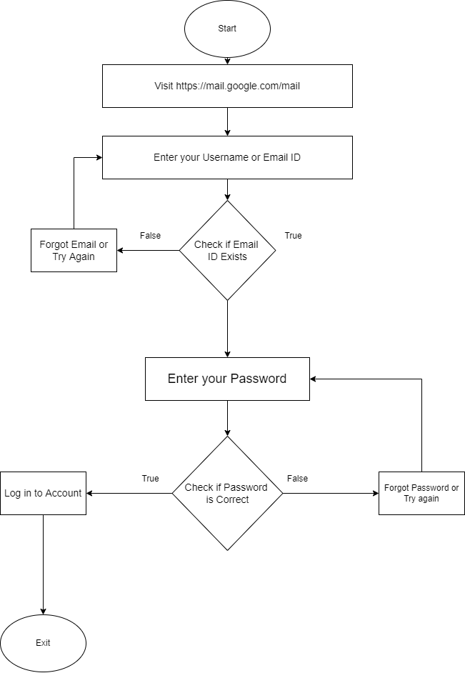

**CONCLUSION:** Thus, learn formalized graphic representation of a given logical sequence.

**FAQ:**

1. Enlist various rules to write algorithms.

A finite set of steps that must be followed to solve any problem is called an **algorithm**. Algorithm is generally developed before the actual coding is done. It is written using English like language so that it is easily understandable even by non-programmers.

Some Rules to Follow are:

* + - 1. Determine the outcome of your code.
      2. Decide on a starting point. Finding your starting and ending point are crucial to listing the steps of the process. To determine a starting point, determine the answers to these questions:
* What data/inputs are available?
* Where is that data located?
* What formulas are applicable to the issue at hand?
* What are the rules to working with the available data?
* How do the data values relate to each other?
  + - 1. Find the ending point of the algorithm. As with the starting point, you can find the end point of your algorithm by focusing on these questions:
* What facts will we learn from the process?
* What changes from the start to the end?
* What will be added or no longer exist
  + - 1. List the steps from start to finish.

These are the characteristics of a good and correct algorithm −

* Has a set of inputs
* Steps are uniquely defined
* Has finite number of steps
* Produces desired output